**Quantification of mRNA Levels in Yeast**

Author: Syed Bilal Hussain [52206697] || MSc Data Science [2022/2023]   
Supervisor: Dr. Andrew Angel || University of Aberdeen

**1. Abstract**

Quantification of mRNA levels is critical for the study of eukaryotic cells such as yeast. The handful existing pipelines that allow such quantification on smFISH images, although impressive, have their own advantages and disadvantages. One that has improved quite a lot in the past few years and is among the best for such quantification is FISH-quant’s Big-FISH package for Python. It offers excellent functions to segment nuclei and cells, detect spots and compute various features from the generated data.

One major drawback, however, is that Big-FISH requires manual user input for the threshold value for nucleus segmentation and cell segmentation. This is a tedious approach, especially when dealing with a large set of images. We have attempted to solve this using two methods: a) calculating the threshold using the Mode and Standard Deviation of the given image

b) predicting the threshold using various features from the image as input

We then checked and compared their performance. The main assessment criteria was the number of outliers detected using Tukey’s Method. Using ML led to a better performance – About 400 more cells were detected, slightly lesser outliers were produced, and the Upper Bounds of Tukey’s Fences were now in a smaller range.

The result is a pipeline that is specialized for the data obtained by the Mellor Group and that does not require additional user input to determine thresholds.

Apart from this, we also conducted some additional analysis on the generated data. We looked at the method of mRNA production, specifically, Transcription Bursting. This was done using the Kolmogorov–Smirnov test to check for Poissonian distribution in the mRNA produced. We also compared the mRNA production between genes, and between different sets of the same gene. This was achieved using the Mann–Whitney U test.

**2. Introduction**

Cells can be studied by quantifying the amounts of RNA in them. The goal of this project is to develop a pipeline that can be used in the study of yeast cells by quantifying the RNA in the smFISH1,2 images of yeast.

Yeast was selected as there are about 6000 genes in a yeast cell which undergo a metabolic cycle. Around 30% of them have a high degree of similarity to function in human cells. So, studying these helps us to understand the basics of related metabolic disorders in human beings, like obesity, or it can help us to understand biological cycles in human beings, like the circadian rhythm. It can also help us to understand altered metabolic states, which are seen in cancers. Furthermore, yeast cells are a more tractable system, i.e., it is much easier to study yeast, compared to mammals or human beings.

In order to aid researchers in conducting such studies, methods are required for accurate quantification. Pipelines exist but there are multiple drawbacks. Our aim is to develop improvements to existing pipelines using machine learning and make them not only effective, but also user-friendly – requiring minimal input from the user and presenting the output in an easy-to-understand manner.

**3. Data**

The data comes from Mellor Lab3 and is hosted on Mendeley Data4, published on March 7, 2018. The data has been collected using a technique called smFISH, or, Single Molecule Fluorescence In Situ Hybridization. It is a powerful technique to study gene expression in single cells due to its ability to detect and count individual RNA molecules.

The data consists of microscopy images from smFISH in the standard format for the output from deltavision microscopes (.dv files). There are overall 212 .dv files. The data provides us with FISH images of five genes, namely, ATP4, GCV3, HMS2, TIM17 and URA4. These genes are further divided by dates into 2-6 sets. The total number of such sets (folders) is 16.

Each .dv file has the shape (Z, C, X, Y), where,

X is the horizontal position in space [0 to 1023]

Y is the vertical position in space [0 to 1023]

Z is the depth position in space [0 to 20]

and C is the colour channel [0 or 1].

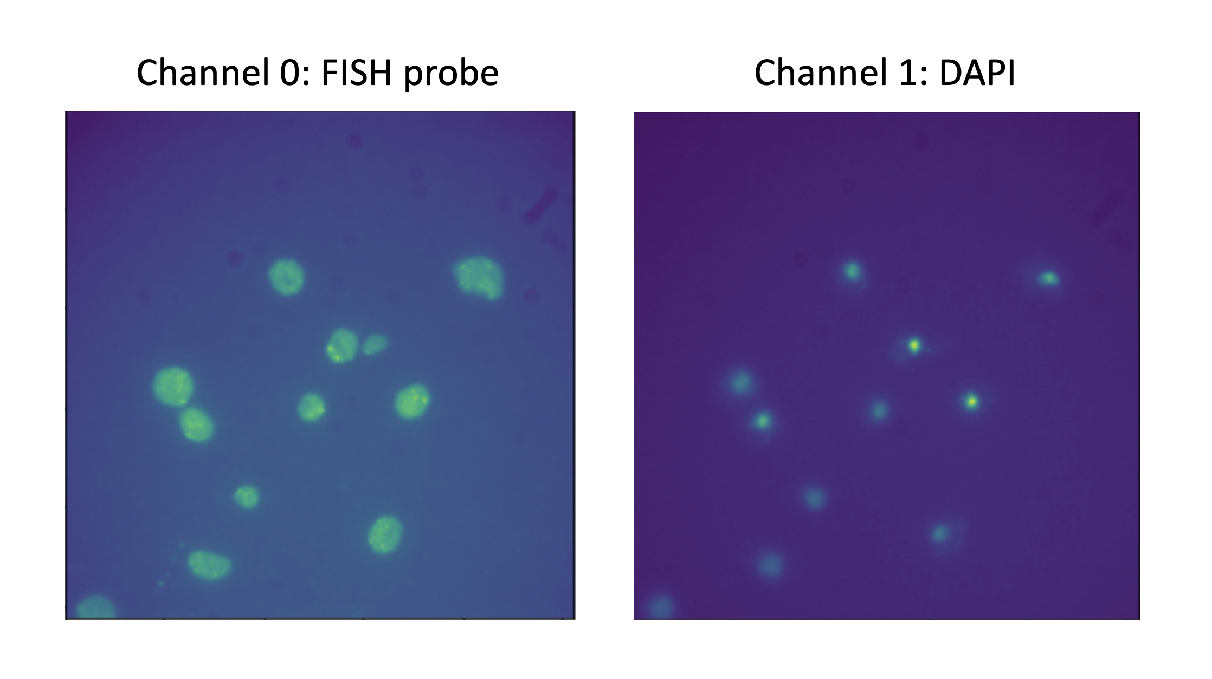

Fig 1. Example images of a .dv file showing the FISH probe image (channel 0) [Left] and the DAPI image (channel 1) [Right]

Channel 0 [Fig 1 Left] shows us the fluorescent probes used during smFISH. This will be used for spots detection and cell segmentation.

Channel 1 [Fig 1 Right] shows us the signal from DAPI staining. DAPI is a fluoroscent stain that binds strongly to DNA, which is present in the nucleus. So, this will be used for nucleus segmentation.

**4. Tools**

We have used the big-fish package from the FISH-quant5 project. This package is highly developed and documented6. More importantly, it is modular, making it useful for creation of a custom analysis pipeline. It also offers support for .dv files.

All code was developed in the Jupyter notebook environment and can be found in the supplementary materials.

**5. Methods**

**5.1. Detect Spots**

The first step in the pipeline is to detect the spots in the RNA image (channel 1). This can be done by calling the *detect_spots()* function of Big-FISH and giving the image as an input. The function calculates a threshold for the image and returns the 2D coordinates of the spots detected. The function also allows the user to give a list of images as the input. It calculates a single threshold for all the images in the list and uses it on all the images. This returns the 3D coordinates of the detected spots which are saved as NumPy arrays.

Note: The user need not worry about the extra spots detected outside the cells (see Fig 2) as we will be segmenting later in the pipeline and counting only within the cell (and nucleus) boundaries.

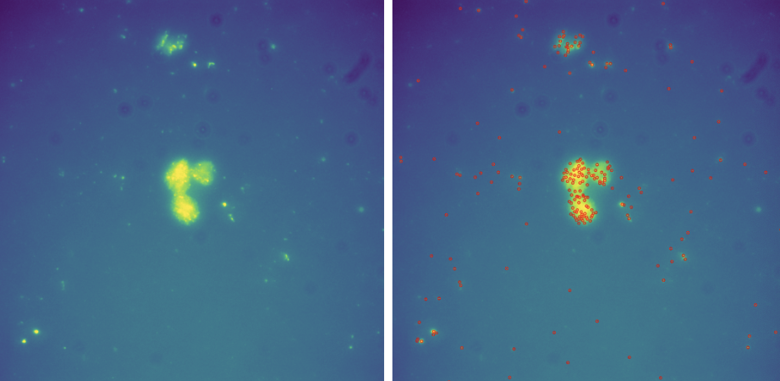

Fig 2. Example of a large number of extra spots detected outside the cells  
Left: Plot of a randomly chosen RNA image. Right: Result of detect_spots() on the image

**5.2. Nucleus and Cell Segmentation**

Big-FISH provides us with excellent functions to perform segmentation. However, one major drawback is that it requires the user to enter a threshold for both nucleus and cell segmentation.

To combat this problem, we came up with two solutions.

1. Calculate the threshold using Mode+n*StandardDeviation of the image.  
   For DAPI, we recommend n = 4. And for RNA, n = 1.
2. Predict the threshold using machine learning.

**5.3. Extract cells information and get field-of-view results**

Next, to get cell-wise information, Big-FISH’s *extract_cell()* is used. It uses the segmentation results to crop the image and plots the spots detected, giving us a count of the mRNA detected in each cell. This was first done for a single image to test if all is working well. An example can be seen in figure 3.

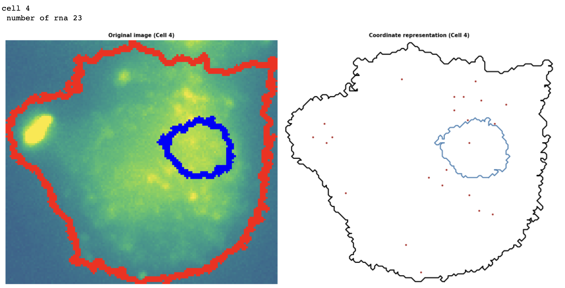

Fig 3. Example of using extract_cell() on an image (displaying results of only one cell for demonstration)

The above was then done for all files and the results are stored for each cell in a .npz file, in the ‘fov’ folder.

Next, we use *compute_features()* to compute the features related to the following:

* Distance
* Intranuclear
* Protrusion
* Dispersion
* Topographic
* Foci
* Area
* Centrosome

These were then packed into a dataframe and saved in a *df_features.csv* file.

Lastly, the df_features.csv files of all genes and their dates were concatenated into one dataframe. Three columns were added to aid our analysis:

- total_rna – Calculated by adding nb_rna_in_nuc and nb_rna_out_nuc

- Gene – Name of the gene

- Date – Date of the gene’s images collection

**5.4. Outlier Detection – Tukey’s Method**

We used Tukey’s method7 to detect outliers in total RNA, nucleus area and cell area. Generally, k=1.5 is used. However, this value for k is a recommendation for ‘normal distributions’. Since these three attributes are not normally distributed, we also used k=3 and compared the results.

We also calculated the percentage of these three attributes that is without outliers (using only k=1.5 for simplicity) to get a measure of how well the pipeline is performing.

**5.5. Determining the Method of mRNA Production**

Standard RNA production gives a Poisson distribution of mRNA, but bursting8 gives a different distribution. We used the Kolmogorov-Smirnov test to compare RNA distributions to a corresponding Poisson distribution with the same mean.

**5.6. Comparing the mRNA Production’s Distribution**

We wanted to compare the total RNA distribution between genes, and between different sets of the same gene. Since the distribution is not normal, and all the sets are independent samples, the Mann–Whitney U test, which is a nonparametric test, is a suitable option here.  
The Null Hypothesis here is that the samples come from the same population. A low p-value means we can reject the Null Hypothesis, i.e., they are showing different behaviour. This is what we expect from different genes. A high p-value might suggest they belong to the same population. This is what we expect from the different sets (separated by dates) of the same gene.

**5.7. Use Machine Learning to Predict Segmentation Threshold**

**5.7.1 Create datasets**

The ML model will have only an image as its input. So, the dataset’s ‘features’ must be something computable from the given image. I decided to try feeding the model the following statistics of the image: min, max, std, mean, mode, 25%, median, 75%.

As for the ‘labels’, to avoid having to manually set the threshold for over 200 images, an initial threshold was set using the Mode+n*Std formula as it gave a starting point and required only slight tweaking of n. By default, we set n=4 for DAPI and n=1 for RNA. This was then changed based on the image’s segmentation output.

This was done for all images and was saved as a .csv file [Fig 4 and 5].

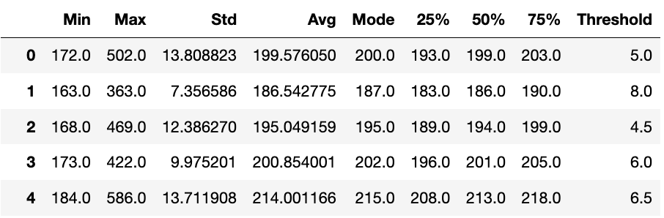

Fig 4. Screenshot of first five rows of the DAPI dataset created for ML

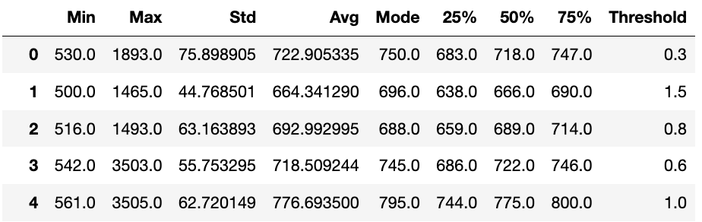

Fig 5. Screenshot of first five rows of the RNA dataset created for ML

Next, few additional features were added to the dataset. First, we calculate the threshold value. We have *n*, *mode* and *std*. Calculate ‘*T_Value*’ using Mode+n*Std. This is our label. This is what we will predict. There are two reasons why we chose to predict this, instead of n. One, we do not know if *mode* and *std* are the best predictors. It could surely be some other feature of the image. Two, the values for n lie in a very small range. A difference of even a fraction leads to different results. It would be in our best interests to keep the margin of error as high as possible. So, we predict *T_Value*, which has a much larger acceptable range.

We also tried adding ratios like Min/Max, Std/Avg, Std/Mode as these might be more correlated to the threshold.

**5.7.2. Model Training**

The data was divided into train and test sets using scikit-learn’s train_test_split() function, with testsize=0.2.

We then tried using the following models:

* Linear Regression
* Random Forests
* Randomized Search for Random Forests (Hyperparameter Tuning)

And the following transformations:

* Log – "it’s often a good idea to transform features with heavy-tailed distributions by replacing them with their logarithm (assuming the feature is positive and the tail is on the right)."9  
  Examining the histograms showed ‘Max’ and ‘Std’ exhibiting these kinds of distributions. So, we take a log of these two features.
* Ratios – Calculating certain ratios could lead to higher correlation to the threshold. So, we tried adding them too.
* Scaling – "With few exceptions, machine learning algorithms don’t perform well when the input numerical attributes have very different scales."10  
  We chose StandardScaler() as this is better for data with outliers.

We trained an ML model using a combination of these transformations and chose the best one. For the ‘Performance Measure’ metric, we compared the Cross Validation Mean (RMSE) of the models. We then reran the pipeline using our preferred model.

**5.7.3. Comparing ML and Our Method**

First, the models were evaluated on the test set. The MSE of using ML and using our method was compared to see if the ML approach was performing better or worse than our Mode+n*Std method.

Next, we compared the number of cells detected. This was done due to two reasons. One, a low DAPI threshold leads to merging of the nuclei. So, instead of 2 (or more) cells, it is counted as 1. Secondly, a high DAPI/RNA threshold results in the missing of a few DAPI/RNA.

So, a good segmentation will lead to a higher count of cells.

Lastly, we compared the outliers. Ideally the percentage of data without outliers should be more than before.

**6. Results**

**6.1. Spots Detection**

Initially we attempted to use the detect_spots() function on all images. This resulted in clear errors when a single image has a 'cluster' or peaks of very high intensity, For example, see Figure 6.

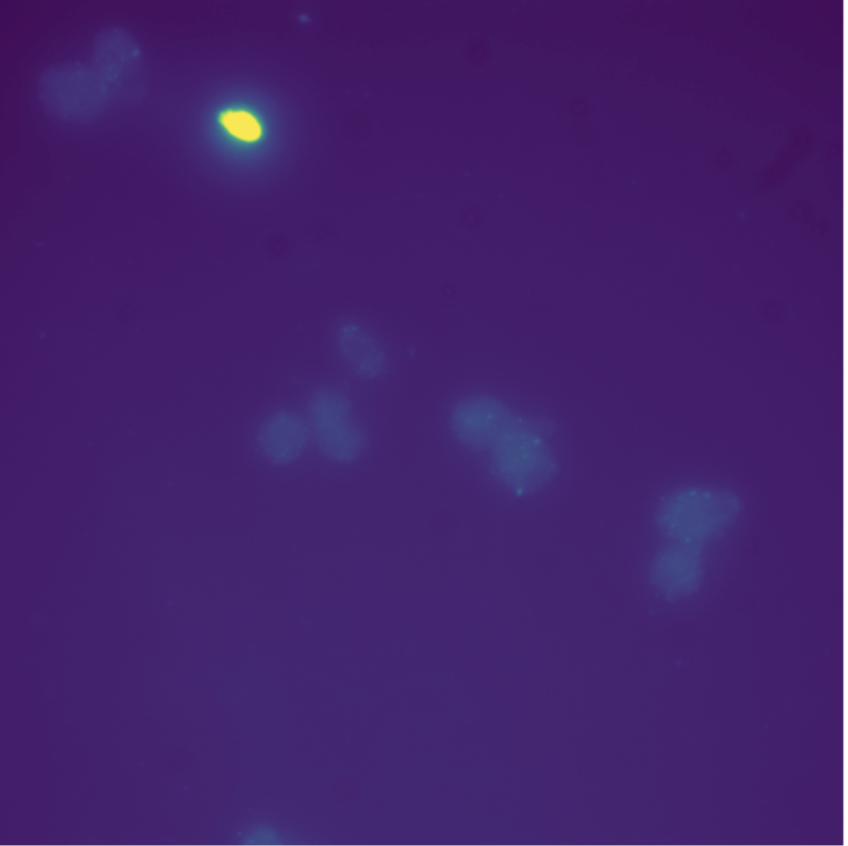

Fig 6. Gcv3_20April, file ‘*BY_Gcv3-GFP_GFPprobe_MW_13april_combo_02_R3D.dv*’ [RNA channel]

Not all images in the set have such clusters. Giving this list as an input results in a threshold selected that is too high. A simple solution is to run the function on individual images.

Giving all images in the set as input to detect_spots() (threshold calculated: 41) [Fig. 7]:

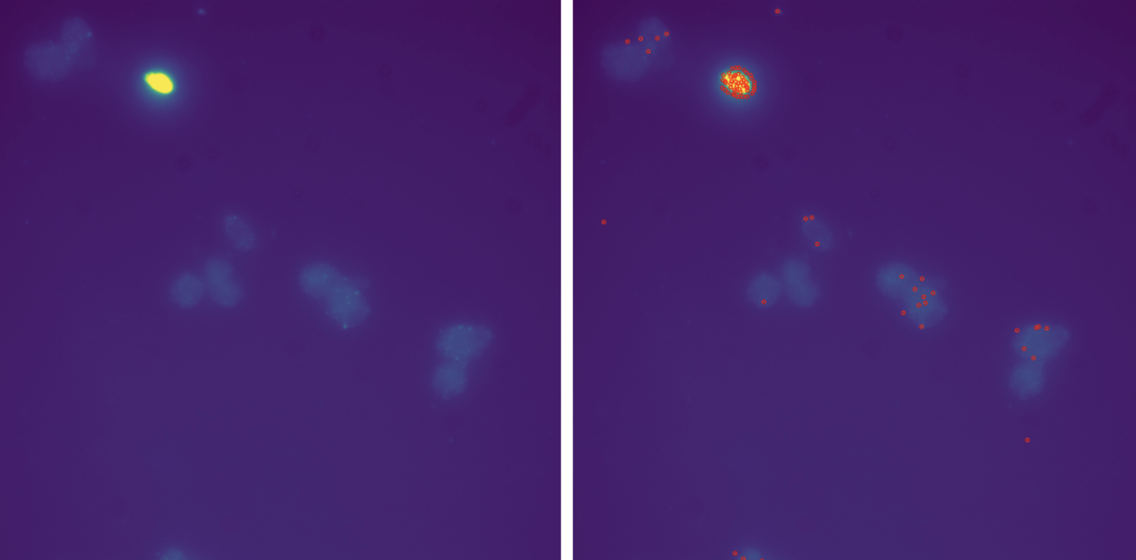

Fig 7. Left: Example of an RNA image; Right: Example showing the spots detected using *detect_spots()*

Giving only this particular image as input to *detect_spots()* (threshold calculated: 28) – More spots detected [Fig. 8]

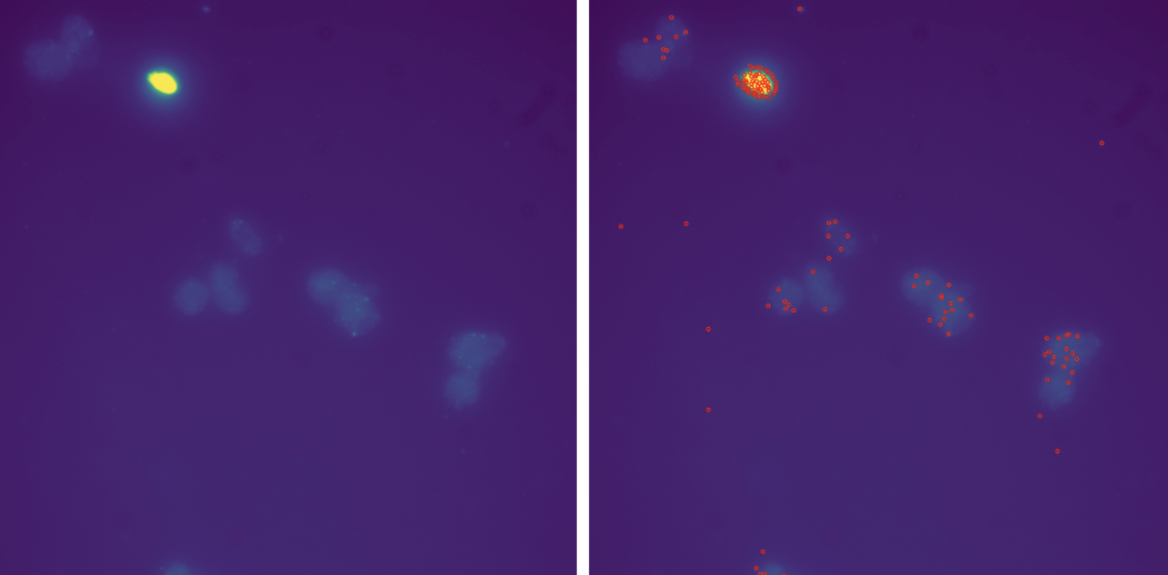

Fig 8. Left: Example of an RNA image (same as Fig 10 -- Left); Right: Example showing the spots detected using *detect_spots()* (more than Fig 10 -- Right)

Therefore, *detect_spots*() was run on individual files using a loop.

**6.2. Nucleus and Cell Segmentation**

As mentioned earlier, Big-FISH requires the user to manually input the threshold. Suggested starting values in the big-FISH GitHub example notebooks11 produced no detected cells, as can be seen in fig 9.

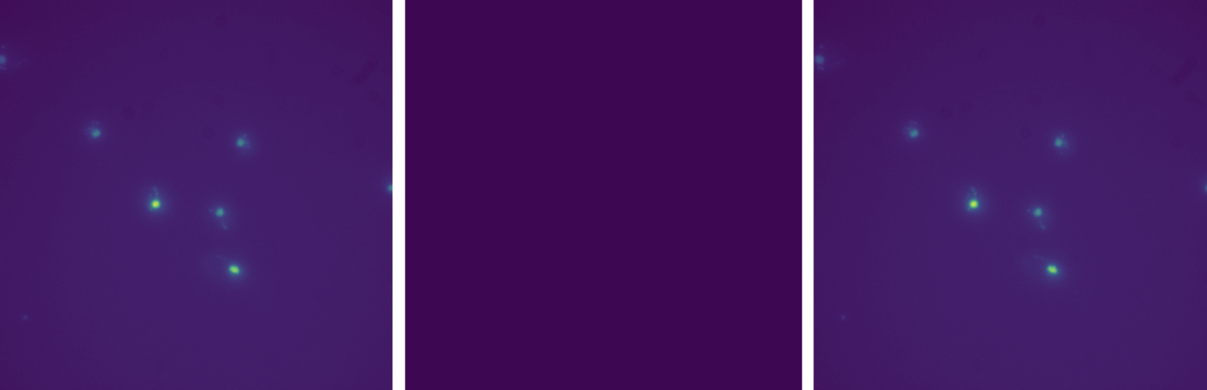

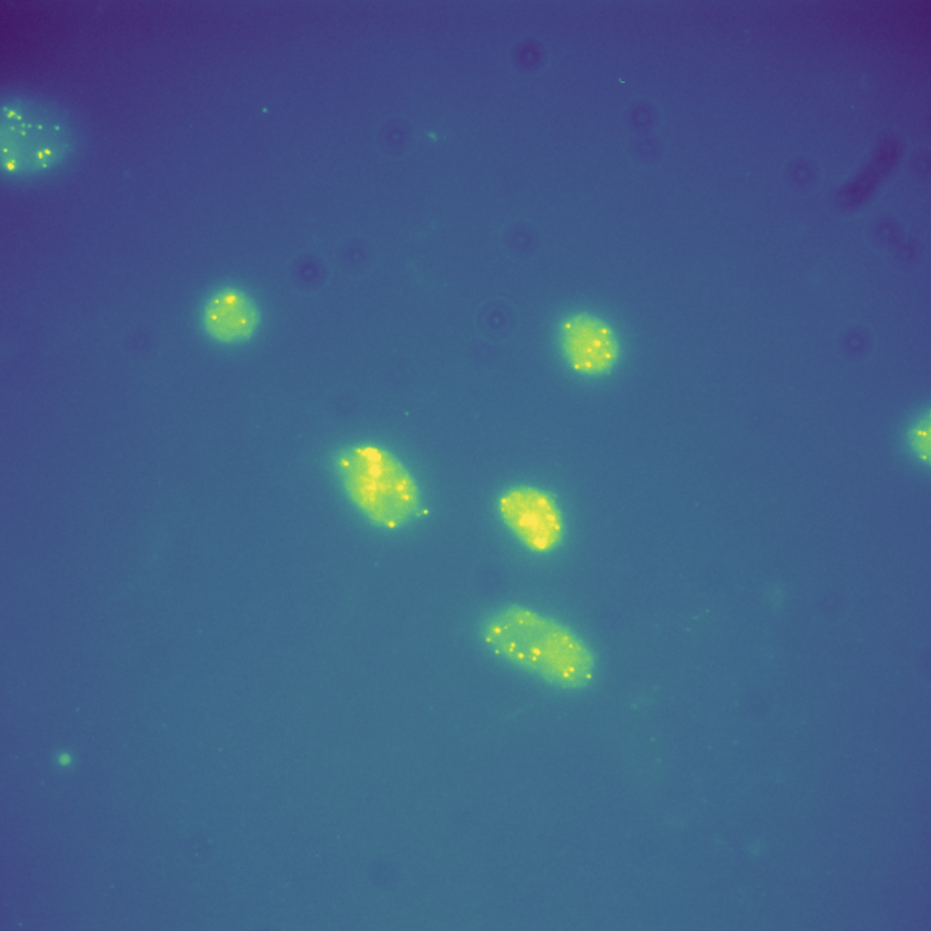

Fig 9. Trying the thresholds used in big-fish-examples on github. No nucleus segmentation [top] and no cell segmentation [bottom]

To solve this, I came up with the following solution: calculate the threshold using Mode+n*Std of the image. I noticed I could get very close to the optimal threshold by adding 2*Std to the Mode of the image.

There are two main cases where segmentation could go wrong:

Case 1: If the threshold is too high, it will lead to missing nuclei/cells. E.g. [Fig 10]:

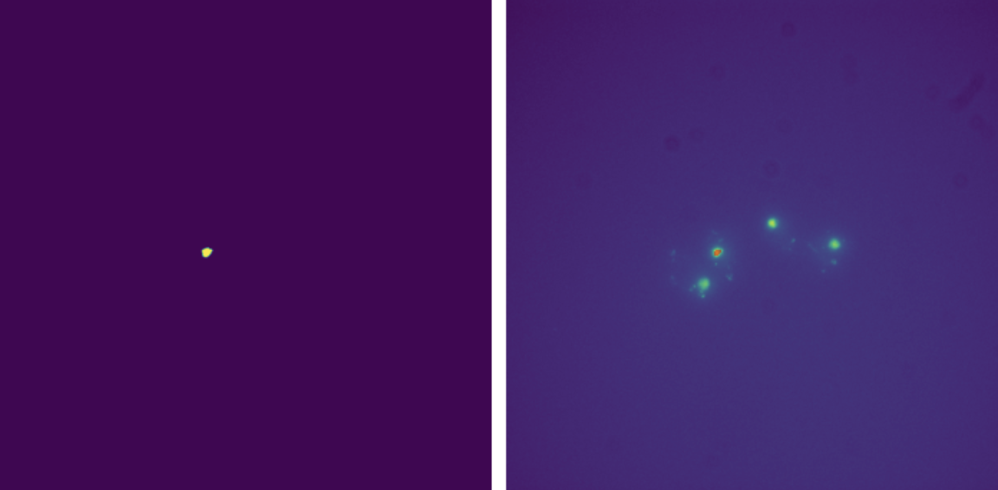 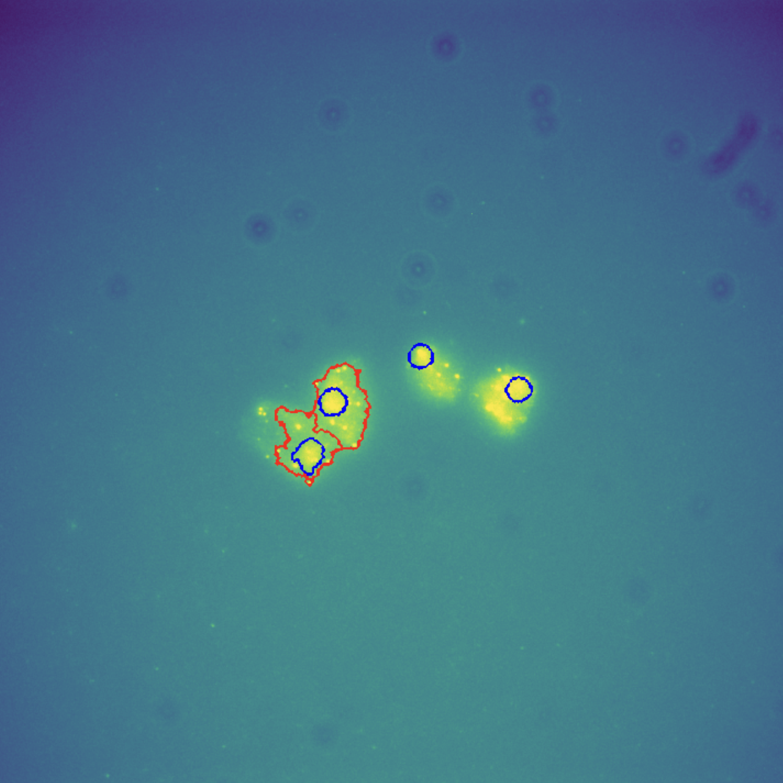

Fig 10. Example demonstrating poor segmentation due to threshold being too high. Results in missing nuclei (detected only 1 out of 4) and cells (detected only 2 out of 4)

Case 2: If the threshold is too low, merging nuclei and having too big cell boundaries [Fig 11]:

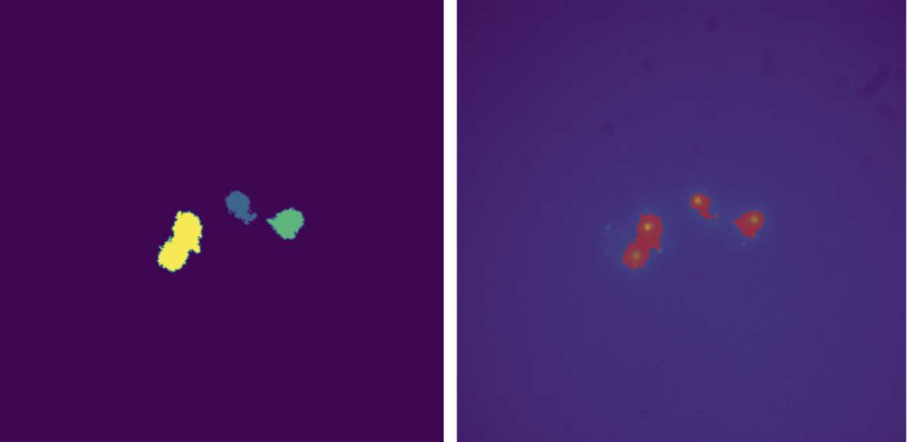 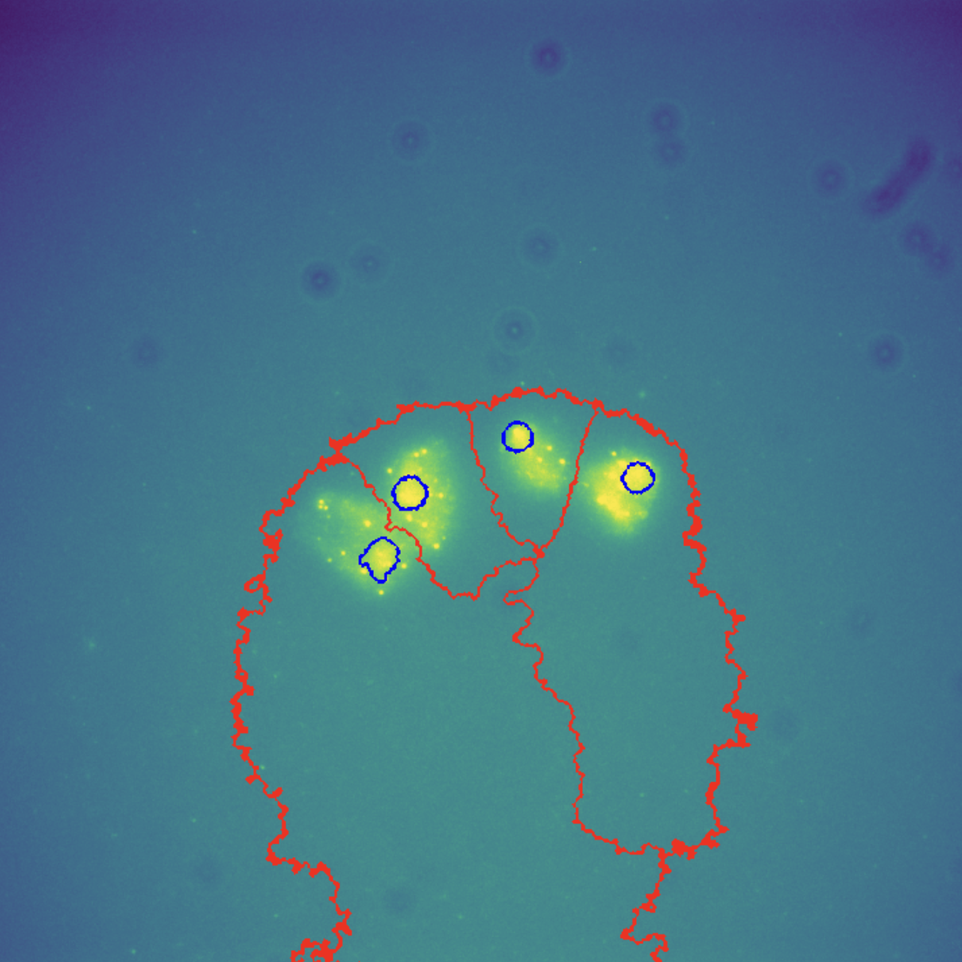

Fig 11. Example demonstrating poor segmentation due to threshold being too low. Results in merging nuclei (merged 2 in this case) and having cell boundaries that are too big

This is what the segmentation will look like using optimal thresholds [Fig 12]:

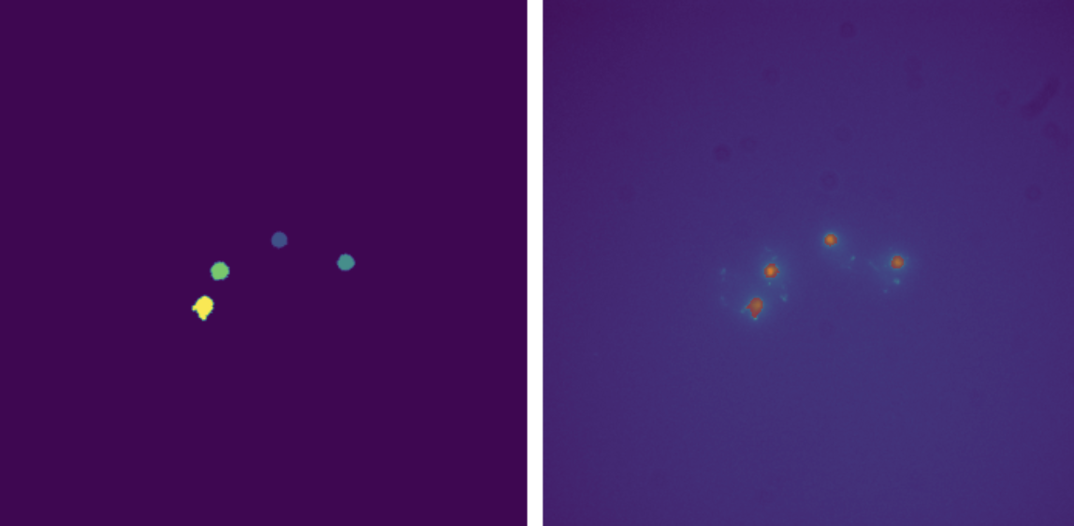 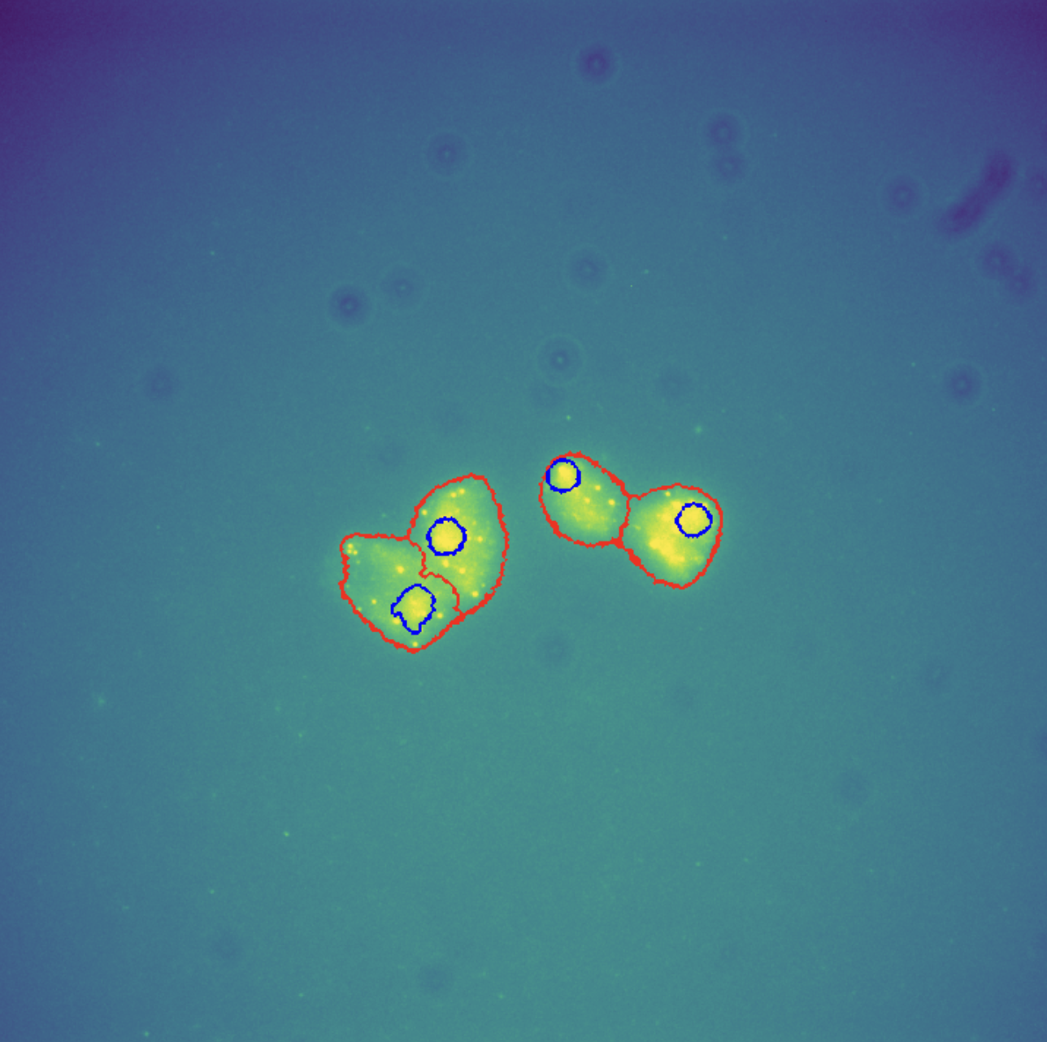

Fig 12. Example of perfect segmentation (using our method!)

Using this approach yielded excellent results. On experimenting with multiplying different constants to Std, the following resulted in the best segmentations:

* Mode+4*Std for DAPI
* Mode+Std for RNA

It worked on all images. It was not perfect, but 80-90% of the nuclei and cells were segmented correctly. All done automatically, without requiring any input from the user.

**6.3. Outliers Detection**

Number of outliers in total RNA, nucleus area and cell area were calculated using Tukey’s method, using k=1.5 and k =3.

Note: We are comparing here k=1.5 and k=3. But, for simplicity’s sake, we will be using k=1.5 for further analysis.

|  |  |  |  |  |  |
| --- | --- | --- | --- | --- | --- |
| Total RNA |  |  | |  | |
|  |  | **K = 1.5** | | **K = 3** | |
| Gene | **Date Set** | **Upper Bound** | **No. of outliers** | **Upper Bound** | **No. of outliers** |
| ATP4 | 20 April | 31.0 | 9 | 43.0 | 2 |
| 30 June | 24.5 | 4 | 35.0 | 2 |
| 30 May | 32.5 | 5 | 46.0 | 3 |
| 31 May | 32.5 | 8 | 49.0 | 6 |
| GCV3 | 20 April | 64.25 | 11 | 98.0 | 4 |
| 30 June | 17.375 | 3 | 26.0 | 1 |
| 30 May 02 | 8.5 | 26 | 13.0 | 25 |
| 31 May | 166.25 | 7 | 260.0 | 4 |
| 31 May 12 | 22.75 | 3 | 34.0 | 2 |
| HMS2 | 10May07 | 41.5 | 7 | 61.0 | 3 |
| 22May07 | 53.0 | 1 | 77.0 | 0 |
| TIM17 | 06July | 14.0 | 6 | 20.0 | 2 |
| 22April | 10.5 | 0 | 15.0 | 0 |
| 31May | 13.75 | 0 | 20.5 | 0 |
| URA4 | 06July | 37.5 | 7 | 54.0 | 1 |
| 22April | 21.0 | 8 | 30.0 | 1 |
| ATP4 | All | 30.5 | 27 | 44.0 | 12 |
| GCV3 | All | 22.0 | 61 | 34.0 | 47 |
| HMS2 | All | 48.5 | 7 | 71.0 | 1 |
| TIM17 | All | 15.5 | 5 | 23.0 | 1 |
| URA4 | All | 30.5 | 10 | 44.0 | 5 |

Table 1. Comparison of using K=1.5 and K=3 for outlier detection in total RNA using Tukey’s method

From Table 1, the results appear very good for TIM17 and URA4.

The results of GCV3 are concerning. Not only do they have the most outliers, but look at the upper bounds of GCV3_31May. That does not seem right. This might be due to a lot of direct laser reflection from the slides or some potential experimental error.

Percentage of total RNA (mRNA count in each cell) without outliers (using k=1.5) [Table 2]:

|  |  |  |  |  |  |
| --- | --- | --- | --- | --- | --- |
|  |  |  |  |  |  |
| ATP4 | GCV3 | HMS2 | TIM17 | URA4 | All |
| 94.33 | 88.64 | 97.06 | 98.09 | 95.43 | 93.82 |

Table 2. Percentage of total RNA without outliers for each gene and for the full dataset

Table 2 shows outstanding results for TIM17. GCV3 had the worst performance, but 88% is not bad. Overall, over 93% of the total RNA was without outliers.

|  |  |  |  |  |  |
| --- | --- | --- | --- | --- | --- |
| Nucleus Area |  |  | |  | |
|  |  | **K = 1.5** | | **K = 3** | |
| Gene | **Date Set** | **Upper Bound** | **No. of outliers** | **Upper Bound** | **No. of outliers** |
| ATP4 | 20 April | 1847.5 | 6 | 2665.0 | 3 |
| 30 June | 2033.0 | 7 | 2897.0 | 2 |
| 30 May | 2840.0 | 14 | 4031.0 | 9 |
| 31 May | 3153.5 | 2 | 4478.0 | 1 |
| GCV3 | 20 April | 1152.375 | 4 | 1569.75 | 3 |
| 30 June | 1697.75 | 11 | 2389.25 | 2 |
| 30 May 02 | 2007.5 | 16 | 2769.5 | 7 |
| 31 May | 4159.0 | 1 | 5862.25 | 1 |
| 31 May 12 | 3135.75 | 1 | 4531.5 | 0 |
| HMS2 | 10May07 | 2929.0 | 6 | 4222.0 | 2 |
| 22May07 | 2226.5 | 4 | 3296.0 | 2 |
| TIM17 | 06July | 1181.625 | 13 | 1610.25 | 6 |
| 22April | 1341.0 | 4 | 1863.0 | 1 |
| 31May | 2425.25 | 1 | 3407.0 | 1 |
| URA4 | 06July | 2223.625 | 9 | 3307.75 | 5 |
| 22April | 1266.75 | 3 | 1731.0 | 0 |
| ATP4 | All | 2255.75 | 42 | 3218.75 | 16 |
| GCV3 | All | 2133.5 | 40 | 3041.0 | 12 |
| HMS2 | All | 2573.0 | 9 | 3725.75 | 5 |
| TIM17 | All | 1479.5 | 19 | 2072.75 | 11 |
| URA4 | All | 1796.5 | 14 | 2606.5 | 7 |

Table 3. Comparison of using K=1.5 and K=3 for outlier detection in nucleus area using Tukey’s method

Again, the upper bounds in GCV3_31May are concerning [Table 3].

Percentage of nucleus area without outliers [Table 4]:

|  |  |  |  |  |  |
| --- | --- | --- | --- | --- | --- |
|  |  |  |  |  |  |
| ATP4 | **GCV3** | **HMS2** | **TIM17** | **URA4** | **All** |
| 91.18 | 92.55 | 96.22 | 92.75 | 93.61 | 93.07 |

Table 4. Percentage of nucleus area without outliers for each gene and for the full dataset

Table 4 shows 90%+ of the nucleus area in all cases is outlier-free.

|  |  |  |  |  |  |
| --- | --- | --- | --- | --- | --- |
| Cell area |  |  | |  | |
|  |  | **K = 1.5** | | **K = 3** | |
| Gene | **Date Set** | **Upper Bound** | **No. of outliers** | **Upper Bound** | **No. of outliers** |
| ATP4 | 20 April | 13476.5 | 6 | 18305.0 | 1 |
| 30 June | 16294.5 | 6 | 22722.0 | 1 |
| 30 May | 16534.5 | 15 | 22488.0 | 4 |
| 31 May | 20992.0 | 2 | 28762.0 | 0 |
| GCV3 | 20 April | 20406.625 | 0 | 29654.5 | 0 |
| 30 June | 14052.25 | 10 | 19358.5 | 1 |
| 30 May 02 | 12333.875 | 12 | 16298.0 | 1 |
| 31 May | 23680.0 | 2 | 32515.75 | 1 |
| 31 May 12 | 11979.0 | 1 | 15913.5 | 0 |
| HMS2 | 10May07 | 15228.0 | 5 | 20724.0 | 2 |
| 22May07 | 12287.0 | 6 | 16619.0 | 1 |
| TIM17 | 06July | 12862.75 | 3 | 17355.25 | 1 |
| 22April | 13970.5 | 2 | 19204.0 | 2 |
| 31May | 19178.75 | 2 | 27104.0 | 0 |
| URA4 | 06July | 12716.625 | 5 | 18010.5 | 2 |
| 22April | 14769.0 | 4 | 19936.5 | 1 |
| ATP4 | All | 17400.25 | 26 | 24317.5 | 6 |
| GCV3 | All | 14704.0 | 25 | 20221.0 | 4 |
| HMS2 | All | 14755.375 | 7 | 20240.5 | 2 |
| TIM17 | All | 14175.25 | 8 | 19480.75 | 5 |
| URA4 | All | 13749.5 | 12 | 19163.0 | 3 |

Table 5. Comparison of using K=1.5 and K=3 for outlier detection in cell area using Tukey’s method

Percentage of cell area without outliers [Table 6]:

|  |  |  |  |  |  |
| --- | --- | --- | --- | --- | --- |
|  |  |  |  |  |  |
| ATP4 | **GCV3** | **HMS2** | **TIM17** | **URA4** | **All** |
| 94.53 | 95.34 | 97.05 | 96.94 | 94.52 | 95.38 |

Table 6. Percentage of cell area without outliers for each gene and for the full dataset

Again, excellent results. In almost all cases, over 95% of the cell area data is outlier-free.

**6.4. Results of performing the Kolmogorov-Smirnov Test on total RNA**

The goal is to test if the total RNA is distributed according to the Poisson distribution. The motive behind this is to test for Transcriptional Bursting. A non-Poissonian distribution of the mRNA produced points to the occurrence of bursting in that particular gene.

To achieve this, we used the Kolmogorov–Smirnov test, which is used to test the ‘goodness of fit’ between two samples. We used the one-sample KS Test as we are testing against an assumed Poisson distribution. A KS test will enable the user to find genes exhibiting a non-Poissonian distribution, so that researchers can conduct further studies on these particular sets of genes.

|  |  |  |  |
| --- | --- | --- | --- |
| Gene | Date Set | P-value | P-value (without outliers) |
| ATP4 | 20 April | 0.002 | 0.038 |
| 30 June | 0.002 | 0.002 |
| 30 May | 4.756e-06 | 0.0008 |
| 31 May | 1.447e-17 | 0.0016 |
| GCV3 | 20 April | 2.418e-21 | 0.0012 |
| 30 June | 8.787e-08 | 1.5423e-06 |
| 30 May 02 | 1.349e-91 | 1.7796e-06 |
| 31 May | 6.568e-22 | 1.239e-12 |
| 31 May 12 | 6.953e-07 | 0.866 |
| HMS2 | 10May07 | 7.953e-11 | 4.337e-07 |
| 22May07 | 2.664e-05 | 3.529e-05 |
| TIM17 | 06July | 0.014 | 0.007 |
| 22April | 0.0007 | 0.0008 |
| 31May | 0.044 | 0.0437 |
| URA4 | 06July | 4.913e-08 | 0.0004 |
| 22April | 0.0009 | 0.0134 |
| ATP4 | All | 3.799e-27 | 3.906e-10 |
| GCV3 | All | 4.011e-224 | 4.5356e-26 |
| HMS2 | All | 7.608e-17 | 4.752e-12 |
| TIM17 | All | 3.411e-05 | 2.609e-07 |
| URA4 | All | 2.157e-13 | 1.875e-06 |

Table 7. KS Test to check for Poisson Distribution in total RNA(with and without outliers)

Table 7 shows P-value was below 0.05 for all. So, apparently, none exhibit Poisson distribution. Especially GCV3, having extremely low p-values.

There was one slight exception though. TIM17_31May had a p-value of 0.0437. Although technically it does mean it is not a Poisson distribution, it might be something to investigate.

It is a definite possibility that the outliers are throwing things off. So, using K=1.5 and eliminating the outliers, we performed the KS tests again. Only the total RNA of GCV3_31May12 seems to be exhibiting a Poisson distribution.

One thing to note is that removing the outliers is drastically increasing the p-value in GCV3.

**6.5. Results of performing the Mann–Whitney U Test on total RNA**

We are testing results from the same genes but different experiments to see if they appear to have different distributions (which we do not expect)

From Table 8, we see that most of the date sets of a particular gene had a very low p-value, indicating different population, which we were not expecting. This could mean:

* Something went wrong with the experiment.
* The image analysis did not work so well for one or more sets.
* The size of the experiments was too small.
* Or, the conditions under which the experiments were done on the different dates were not consistent.

When combining the results of the different date sets of a particular gene and using them, this must be kept in mind.

|  |  |  |  |  |
| --- | --- | --- | --- | --- |
| Gene | Date 1 | Date 2 | P-value | P-value (without outliers) |
| ATP4 | 20April | 30June | 1.218e-10 | 1.554e-09 |
| 30May | 0.735 | 0.754 |
| 31May | 0.005 | 1.432e-05 |
| 30June | 30May | 5.25e-10 | 3.666e-10 |
|  | 31May | 0.665 | 0.255 |
|  | 30May | 31May | 0.008 | 7.687e-06 |
| GCV3 | 20April | 30June | 2.72e-10 | 1.826e-06 |
| 30May02 | 2.671e-14 | 8.498e-16 |
| 31May | 0.054 | 0.023 |
| 31May12 | 0.032 | 0.011 |
| 30June | 30May02 | 2.137e-14 | 8.976e-26 |
|  | 31May | 1.131e-15 | 9.019e-13 |
|  | 31May12 | 0.134 | 0.745 |
|  | 30May02 | 31May | 8.424e-17 | 1.136e-19 |
|  | 31May12 | 0.0001 | 1.813e-05 |
|  | 31May | 31May12 | 0.0006 | 3.273e-05 |
| HMS2 | 10May07 | 22May07 | 5.654e-05 | 1.363e-06 |
| TIM17 | 06July | 22April | 0.0004 | 0.004 |
|  | 31May | 0.029 | 0.096 |
| 22April | 31May | 0.695 | 0.695 |
| URA4 | 06July | 22April | 5.933e-08 | 3.999e-10 |

Table 8. MWU Test to compare similarity of the total RNA distribution between different date sets for the same gene (with and without outliers). Expectation was high p-value (>0.05)

We of course tried combining the results of the date sets and compared the genes. A high p-value between different gene pairs should indicate similarity. Yes, we cannot conclude with full certainty that these pairs have similar behaviour as we have established earlier that combining the date sets is to be done with caution. But, if you do combine the date sets, you see that ATP4—URA4 and GCV3—TIM17 have a p-value higher than 0.05. This prompts further investigation.

|  |  |  |  |
| --- | --- | --- | --- |
| Gene 1 | Gene 2 | P-value | P-value (without outliers) |
| ATP4 | GCV3 | 6.458e-47 | 1.26e-74 |
| HMS2 | 2.076e-10 | 2.146e-13 |
| TIM17 | 1.761e-56 | 3.161e-56 |
| URA4 | 0.22 | 0.282 |
| GCV3 | HMS2 | 2.036e-43 | 1.904e-68 |
| TIM17 | 0.208 | 9.034e-05 |
| URA4 | 2.367e-26 | 1.741e-43 |
| HMS2 | TIM17 | 2.500e-54 | 6.129e-55 |
| URA4 | 2.631e-09 | 5.558e-11 |
| TIM17 | URA4 | 7.961e-36 | 1.07e-35 |

Table 9. MWU test to compare similarity of the total RNA distribution between different genes. High p-value (>0.5) shows the distributions come from the same population

When comparing the p-values after removing outliers [Table 9], we notice GCV3—TIM17 are no longer similar while ATP4—URA4 retain their similarity.

**6.6. Using Machine Learning to Predict Segmentation Threshold**

**6.6.1. Correlation analysis of threshold with other attributes**

Having a quick look at the correlation of threshold with the other attributes before beginning model training:

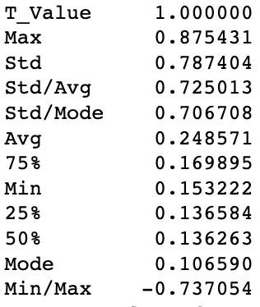

For the DAPI signal, the correlation was seen to depend weakly on the Mode, which goes against our hypothesis. Max and Std are the most correlated. Also, the ratios we calculated have a high correlation too.

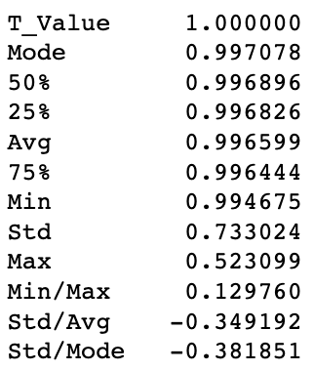

For the RNA (FISH signal) the greatest correlation was the mode and the dependence on the maximum was much less. We observe that the threshold for both DAPI and RNA have a strong positive correlation to standard deviation.

**6.6.2. Model Comparison After Training**

We compared multiple transformations and types of ML models when attempting to automate threshold selection. Following tables [Tables 10 and 11] show the Cross Validation Mean comparisons:

**DAPI**

|  |  |  |  |
| --- | --- | --- | --- |
| Transformation\Model | Linear Regression | Random Forests | Randomized Search for RF |
| Basic | 14.559676 | 18.164846 | 16.692231 |
| Log | 14.551242 | 18.177639 | 17.271980 |
| Ratio | 15.193053 | 18.876655 | 17.219206 |
| Scale | 14.559676 | 18.171564 | 16.684966 |
| Log + Scale | 14.551242 | 18.138723 | 17.232183 |
| Log + Ratio | 15.165516 | 18.736973 | 17.492705 |
| Ratio + Scale | 15.193053 | 18.821026 | 17.213991 |
| Log + Ratio + Scale | 15.165516 | 18.705824 | 17.400765 |

Table 10. Comparison of Cross Validation Mean for combinations of different models and transformations [DAPI]

Table 10 shows Linear Regression with log transformations appears to be the best.

**RNA**

|  |  |  |  |
| --- | --- | --- | --- |
| Transformation\Model | Linear Regression | Random Forests | Randomized Search for RF |
| Basic | 16.831347 | 19.066121 | 19.079266 |
| Log | 16.568626 | 18.759960 | 19.121522 |
| Ratio | 16.749875 | 19.026237 | 19.072807 |
| Scale | 16.831347 | 19.055140 | 19.076405 |
| Log + Scale | 16.568626 | 18.761943 | 19.104986 |
| Log + Ratio | 16.722068 | 19.047475 | 19.187618 |
| Ratio + Scale | 16.749875 | 19.040065 | 19.075496 |
| Log + Ratio + Scale | 16.722068 | 19.052931 | 19.192504 |

Table 11. Comparison of Cross Validation Mean for combinations of different models and transformations [RNA]

Again, Linear Regression with log transformations appears to be the best (for RNA) [Table 11].

I investigated the feature importance for the Randomized Search (for DAPI) and obtained the results shown in Table 12.

|  |  |
| --- | --- |
| 0.449 | Max |
| 0.362 | Std |
| 0.055 | Avg |
| 0.032 | Min |
| 0.028 | 50% |
| 0.028 | Mode |
| 0.024 | 25% |
| 0.019 | 75% |

Table 12. Feature importance results for Randomized Search (DAPI)

*Max* and *Std* are the most important apparently, which was also suggested by the correlation analysis done earlier. So, I trained a Linear Regression model and a Random Forest using only *Max* and *Std* as the features. The Cross Validation Mean for both rose to about 24. This suggests a worse model, but it could also mean my model is overfitting.

**6.6.3. Evaluation of the Linear Regression Models**

For the final DAPI and RNA models, based on the above comparisons, we trained a Linear Regression model with log transformations on Max and Std for each of them.

We then evaluated them on the test set. And, more importantly, we wanted to see if these models are doing better than our Mode+n*Std method.

So I created a new feature (in the test set), ‘My_Threshold’. For DAPI, this was calculated using Mode+4*Std. And for RNA, Mode+Std. The mean squared error against the manually assigned thresholds was calculated for each model, showing the ML performance to be significantly better, Table 13.

|  |  |  |
| --- | --- | --- |
|  | **Using my method** | **Using ML** |
| **DAPI** | 26.761285536286195 | 12.052893067238823 |
| **RNA** | 32.86985681654939 | 15.538325477031046 |

Table 13. Mean Squared Error comparison

**6.7. Comparison of the Two Methods**

We compared the number of cells detected by the ML model and our simple mode+n*std formula. A greater number of cells detected (approximately 20% more) for the ML aproach indicates a superior model as fewer cells are being lost to poor thresholding.

Number of cells detected using our method: 1732

Number of cells detected using ML: 2126

We also compared the gene-wise changes in number of cells [Fig 13]. Cells detected increased for each gene.

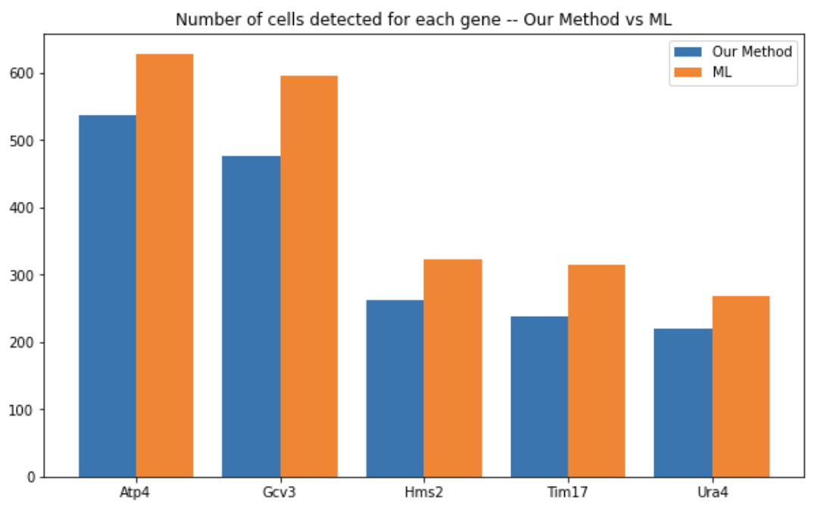

Fig 13. Bar chart comparing the number of cells detected for each gene using our method and using ML

Next, we compare the total RNA.

|  |  |  |
| --- | --- | --- |
| **Statistics** | **Our Method** | **Using ML** |
| Count | 1732 | 2126 |
| Mean | 13.69 | 12.91 |
| Std | 21.90 | 18.56 |
| Min | 0 | 0 |
| 25% | 4 | 4 |
| 50% | 9 | 9 |
| 75% | 16 | 16 |
| Max | 355 | 308 |

Table 14. Statistics on the detected total RNA for the two methods

The data presented in Table 14 shows *Max* has decreased (*Max* is the highest number of mRNA detected in a cell). This is good because that is clearly an outlier, and a lower value here indicates an improvement. Other statistics remain similar. This is also good as we do not expect any drastic changes at least up to 90% since more than 90% of the total RNA was without outliers.

**Comparison of Detected Outliers**

Number of outliers (calculated using Tukey’s method) in total RNA was compared.

|  |  |  |  |  |  |
| --- | --- | --- | --- | --- | --- |
| Total RNA |  |  | |  | |
|  |  | **Our Method** | | **Using ML** | |
| Gene | **Date Set** | **Upper Bound** | **No. of outliers** | **Upper Bound** | **No. of outliers** |
| ATP4 | 20 April | 31.0 | 9 | 30.5 | 7 |
| 30 June | 24.5 | 4 | 23.375 | 6 |
| 30 May | 32.5 | 5 | 32.5 | 2 |
| 31 May | 32.5 | 8 | 36.0 | 7 |
| GCV3 | 20 April | 64.25 | 11 | 26.5 | 2 |
| 30 June | 17.375 | 3 | 18.0 | 4 |
| 30 May 02 | 8.5 | 26 | 8.5 | 30 |
| 31 May | 166.25 | 7 | 62.375 | 10 |
| 31 May 12 | 22.75 | 3 | 30.25 | 3 |
| HMS2 | 10May07 | 41.5 | 7 | 39.0 | 7 |
| 22May07 | 53.0 | 1 | 50.0 | 2 |
| TIM17 | 06July | 14.0 | 6 | 14.0 | 8 |
| 22April | 10.5 | 0 | 10.5 | 1 |
| 31May | 13.75 | 0 | 13.0 | 9 |
| URA4 | 06July | 37.5 | 7 | 37.5 | 10 |
| 22April | 21.0 | 8 | 21.0 | 3 |
| ATP4 | All | 30.5 | 27 | 29.0 | 21 |
| GCV3 | All | 22.0 | 61 | 18.25 | 61 |
| HMS2 | All | 48.5 | 7 | 47.0 | 6 |
| TIM17 | All | 15.5 | 5 | 15.5 | 6 |
| URA4 | All | 30.5 | 10 | 33.0 | 13 |

Table 15. Comparison of number of outliers detectedand the upper bounds in total RNA using Tukey’s method (k=1.5) [our method vs ML]

From Table 15, it appears the ML model performed worse. But this might not necessarily be the case. There are two reasons for this.

First, if you observe the upper bounds, you will notice many of them have been reduced (especially in the next tables – some of them have drastic reductions). A small boundary means increased number of outliers.

Secondly, there are many more cells detected using ML. Increase in the number of cells can lead to an increase in the number of outliers detected.

Therefore, the following is a much better comparison of the two methods:

Percentage of total RNA without outliers [Table 16]:

|  |  |  |  |  |  |  |
| --- | --- | --- | --- | --- | --- | --- |
|  |  |  |  |  |  |  |
|  | **ATP4** | **GCV3** | **HMS2** | **TIM17** | **URA4** | **All** |
| Our Method | 94.33 | 88.64 | 97.06 | 98.09 | 95.43 | 93.82 |
| Using ML | 95.80 | 90.27 | 97.77 | 98.14 | 94.40 | **95.48** |

Table 16. Comparison of percentage of the total RNA without outliers [our method vs ML]

An improvement is seen (in Table 16) for all genes except URA4.

Next, outliers in nucleus area were compared. This is important because an outlier in the nucleus area points to merged segmentation of multiple nuclei, which results in the merging of those cells, which results in an abnormally high count of RNA.

|  |  |  |  |  |  |
| --- | --- | --- | --- | --- | --- |
| Nucleus Area |  |  | |  | |
|  |  | **Our Method** | | **Using ML** | |
| Gene | **Date Set** | **Upper Bound** | **No. of outliers** | **Upper Bound** | **No. of outliers** |
| ATP4 | 20 April | 1847.5 | 6 | 1134.5 | 5 |
| 30 June | 2033.0 | 7 | 1259.0 | 0 |
| 30 May | 2840.0 | 14 | 1354.0 | 0 |
| 31 May | 3153.5 | 2 | 1885.5 | 2 |
| GCV3 | 20 April | 1152.375 | 4 | 1467.75 | 5 |
| 30 June | 1697.75 | 11 | 1583.5 | 14 |
| 30 May 02 | 2007.5 | 16 | 1063.25 | 28 |
| 31 May | 4159.0 | 1 | 1566.75 | 3 |
| 31 May 12 | 3135.75 | 1 | 1721.75 | 2 |
| HMS2 | 10May07 | 2929.0 | 6 | 1414.75 | 6 |
| 22May07 | 2226.5 | 4 | 1718.25 | 11 |
| TIM17 | 06July | 1181.625 | 13 | 962.25 | 10 |
| 22April | 1341.0 | 4 | 1264.0 | 9 |
| 31May | 2425.25 | 1 | 1494.75 | 2 |
| URA4 | 06July | 2223.625 | 9 | 1040.25 | 9 |
| 22April | 1266.75 | 3 | 1390.5 | 8 |
| ATP4 | All | 2255.75 | 42 | 1304.5 | 28 |
| GCV3 | All | 2133.5 | 40 | 1353.75 | 49 |
| HMS2 | All | 2573.0 | 9 | 1528.75 | 21 |
| TIM17 | All | 1479.5 | 19 | 1154.75 | 21 |
| URA4 | All | 1796.5 | 14 | 1112.25 | 19 |

Table 17. Comparison of number of outliers detectedand the upper bounds in nucleus area using Tukey’s method (k=1.5) [our method vs ML]

Table 17 points to worse performance on using ML. However, notice the upper bounds. The range is much smaller for ML. Almost all lie between 1000-1500 whereas when using our method, the range was much bigger.

Percentage of nucleus area without outliers [Table 18]:

|  |  |  |  |  |  |  |
| --- | --- | --- | --- | --- | --- | --- |
|  |  |  |  |  |  |  |
|  | **ATP4** | **GCV3** | **HMS2** | **TIM17** | **URA4** | **All** |
| Our Method | 91.18 | 92.55 | 96.22 | 92.75 | 93.61 | 93.07 |
| Using ML | 95.29 | 92.19 | 93.63 | 93.48 | 92.91 | **93.41** |

Table 18. Comparison of percentage of the nucleus area without outliers (our method vs ML)

Results remained more or less the same.

Lastly, number of outliers for cell area was calculated and compared. Again, outliers in cell area will result in outliers in RNA count.

|  |  |  |  |  |  |
| --- | --- | --- | --- | --- | --- |
| Cell area |  |  | |  | |
|  |  | **Our Method** | | **Using ML** | |
| Gene | **Date Set** | **Upper Bound** | **No. of outliers** | **Upper Bound** | **No. of outliers** |
| ATP4 | 20 April | 13476.5 | 6 | 14800.875 | 7 |
| 30 June | 16294.5 | 6 | 18204.625 | 9 |
| 30 May | 16534.5 | 15 | 15389.0 | 9 |
| 31 May | 20992.0 | 2 | 15525.0 | 1 |
| GCV3 | 20 April | 20406.625 | 0 | 18141.75 | 0 |
| 30 June | 14052.25 | 10 | 16539.5 | 12 |
| 30 May 02 | 12333.875 | 12 | 12360.75 | 8 |
| 31 May | 23680.0 | 2 | 17475.25 | 6 |
| 31 May 12 | 11979.0 | 1 | 13050.375 | 1 |
| HMS2 | 10May07 | 15228.0 | 5 | 16691.75 | 2 |
| 22May07 | 12287.0 | 6 | 13962.75 | 9 |
| TIM17 | 06July | 12862.75 | 3 | 14140.5 | 8 |
| 22April | 13970.5 | 2 | 14662.5 | 1 |
| 31May | 19178.75 | 2 | 25163.25 | 1 |
| URA4 | 06July | 12716.625 | 5 | 15403.0 | 5 |
| 22April | 14769.0 | 4 | 18650.5 | 2 |
| ATP4 | All | 17400.25 | 26 | 16467.25 | 25 |
| GCV3 | All | 14704.0 | 25 | 14588.75 | 28 |
| HMS2 | All | 14755.375 | 7 | 15702.375 | 7 |
| TIM17 | All | 14175.25 | 8 | 15421.25 | 16 |
| URA4 | All | 13749.5 | 12 | 16718.25 | 7 |

Table 19. Comparison of number of outliers detectedand the upper bounds in cell area using Tukey’s method (k=1.5) [our method vs ML]

Results observed were similar to those observed for nucleus area.

Percentage of cell area without outliers [Table 20]:

|  |  |  |  |  |  |  |
| --- | --- | --- | --- | --- | --- | --- |
|  |  |  |  |  |  |  |
|  | **ATP4** | **GCV3** | **HMS2** | **TIM17** | **URA4** | **All** |
| Our Method | 94.53 | 95.34 | 97.05 | 96.94 | 94.52 | 95.38 |
| Using ML | 95.80 | 95.53 | 97.77 | 95.03 | 97.39 | **95.86** |

Table 20. Comparison of percentage of the cell area without outliers (our method vs ML)

Table 20 shows minor improvements, although nothing significant. URA4 appears to have had a noteworthy improvement.

**7. Conclusion**

The main goal of this project was to build a pipeline capable of quantifying mRNA levels in yeast data sets of images taken during FISH experiments. FISH-quant’s Big-FISH library is excellent for accomplishing this, but not perfect. Our project has offered a few solutions to improve on it.

Firstly, Big-FISH offers the user the choice of sending a single image, or a list of images as an input to the detect_spots() function. While sending a list of all your images seems convenient, our experience shows detecting spots image-by-image leads to better results (more spots detected) as it calculates and selects the threshold that is best for that particular image.

Next, segmentation. The functions provided by Big-FISH have one major drawback. They require the user to manually input the thresholds for nucleus and cell segmentation. The user will have to try multiple combinations to get the optimal thresholds. This is not user friendly.

We offered two solutions:

1. Calculate the threshold using:  
   - Mode+4*StandardDeviation for DAPI  
   - Mode+StandardDeviation for RNA
2. Predict the threshold using an ML model

Using the Mode+n*StandardDeviation method, the results were impressive. Although not perfect, the segmentation was good for over 90% of the cells. This is assessed by detecting the outliers (using Tukey’s Method) which showed over 90% of the data was without outliers. This in itself was a big achievement. And, if desiring perfection, our solution offers a starting point which will then require only slight manual tweaking.

Next, to improve our pipeline’s performance, we tried Machine Learning. The main reason was that, from the above solution, we observed a correlation between Threshold and Mode+n*Std. It is possible there were other features, or combination of features of the image that would lead to a better prediction. So, we trained two models, one for DAPI and one for RNA, to predict the thresholds. The features were ‘Min’, ‘Max’, ‘Std’, ‘Avg’, ‘Mode’, ‘25%’, ‘Median’, ‘75%’. As for the labels, we did the segmentation manually for all images and selected the best thresholds.

The models were trained using various methods. Linear Regression using log transformations on Max and Std gave the least RMSE, and so were selected as our final models.

This was then compared with our previous solution. More cells were detected, the ‘Max’ of total RNA was reduced, the Mean Squared Error was reduced by more than 50% using ML, and the overall percentage of total RNA, nucleus area and cell area without outliers was higher.

The result is a pipeline that can automatically and effectively quantify mRNA levels in smFISH images of yeast.

**8. Discussion**

There are a number of ways in which this project could be extended.

Improve the ML model – This can be done by getting a lot more data; trying different models (Polynomial regression, neural networks); testing for overfitting; trying different inputs to the model (histogram of each image with appropriate bin sizes).

Improve spot detection – We currently have no way to assess the performance of spot detection. Analysis of data sets with controls could help with achieving this.

Test the pipeline on different genes, or even different organisms (humans)

Add support for different file formats (images collected using different microscopes)

Use the pipeline to analyse data collected from different phases of the yeast metabolic cycle.

**9. References**

1. Raj A, van den Bogaard P, Rifkin SA, van Oudenaarden A, Tyagi S. Imaging individual mRNA molecules using multiple singly labeled probes. Nat Methods. 2008;5(10):877–879.
2. Femino AM, Fay FS, Fogarty K, Singer RH. Visualization of single RNA transcripts in situ. Science. 1998;280(5363):585–590.
3. Brown T, Howe FS, Murray SC, Wouters M, Lorenz P, Seward E, Rata S, Angel A, Mellor J. Antisense transcription-dependent chromatin signature modulates sense transcript dynamics. Mol Syst Biol. 2018 Feb 12;14(2):e8007. doi: 10.15252/msb.20178007. PMID: 29440389; PMCID: PMC5810148.
4. Mellor, Jane (2018), “Antisense transcription-dependent chromatin signature modulates sense transcription and transcript dynamics”, Mendeley Data, V2, doi: 10.17632/dhnvj4xs5d.2
5. Imbert A, Ouyang W, Safieddine A, Coleno E, Zimmer C, Bertrand E, Walter T, Mueller F. FISH-quant v2: a scalable and modular tool for smFISH image analysis. RNA. 2022 Jun;28(6):786-795. doi: 10.1261/rna.079073.121. Epub 2022 Mar 28. PMID: 35347070; PMCID: PMC9074904.
6. https://big-fish.readthedocs.io/en/stable/index.html
7. Tukey, John. Exploratory Data Analysis. Pearson; 1st Edition. 1977.
8. Zenklusen, D., Larson, D. & Singer, R. Single-RNA counting reveals alternative modes of gene expression in yeast. Nat Struct Mol Biol 15, 1263–1271 (2008). <https://doi.org/10.1038/nsmb.1514>
9. Géron, Aurélien. Hands-On Machine Learning with Scikit-Learn, Keras, and TensorFlow (p. 141). O'Reilly Media. Kindle Edition.
10. Géron, Aurélien. Hands-On Machine Learning with Scikit-Learn, Keras, and TensorFlow (p. 134). O'Reilly Media. Kindle Edition.
11. https://github.com/fish-quant/big-fish-examples/blob/master/notebooks/4%20-%20Segment%20nuclei%20and%20cells.ipynb